29.55: a)

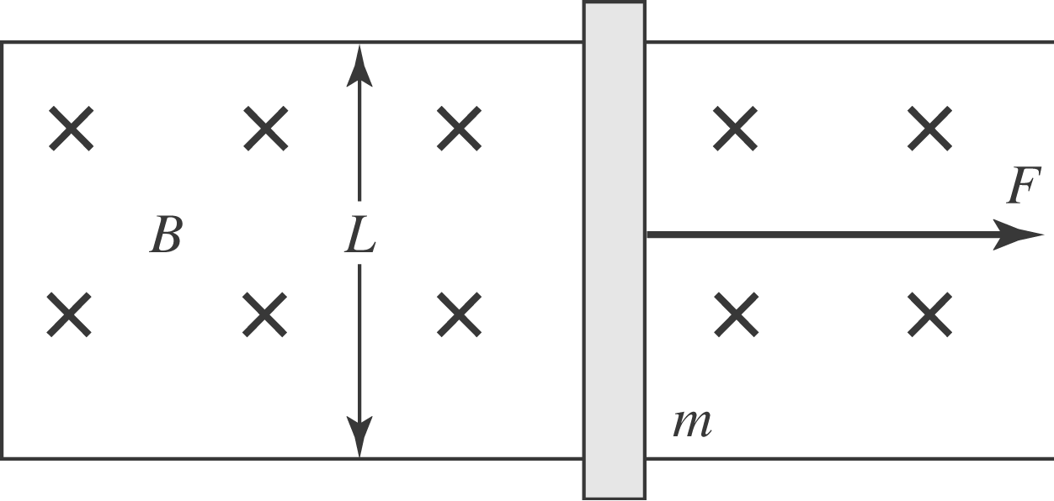

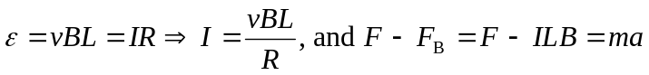
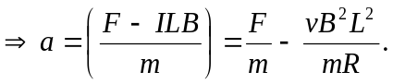
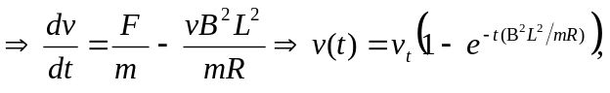 where v_{t} is the terminal velocity calculated in part (b).
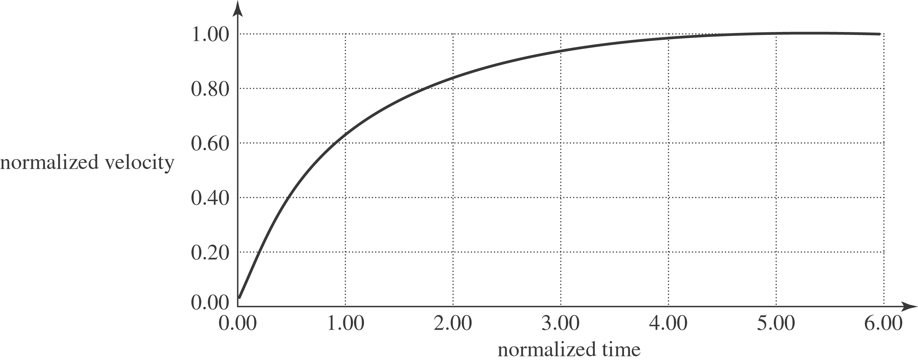

b) The terminal speed 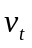 occurs when the pulling force is equaled by the magnetic force: 